**Lesson Title:** Newton’s first and second law

**Subject:** Physics

**Grade:** Lower six (Grade12)

**Week:** Oct 01st – 04th 2024

**Time:** 4 hours 40 minutes

**Number of sessions**:

1. 40 minutes

3- 80 minutes

**Topic:** Newton’s first and second laws

**Essential Benchmark (General Objectives):**

1. Students should be able to understand and explain Newton’s First and Second Laws of Motion.
2. Students should be able to apply these laws to solve real-world problems.

**Lesson Objective(s)**

*Students should be able to:*

1. Correctly define Newton’s First Law and provide examples of inertia.
2. Correctly Define Newton’s Second Law and solve problems using the formula (F = ma).
3. Conduct experiments to observe the effects of force and mass on acceleration.

**Key Skills:**

Communication, collaboration, critical thinking, analytical reasoning, and problem-solving.

**Key Vocabulary:**

Uniform acceleration

**Materials:**

Whiteboard, markers, centimeter ruler, graph paper, calculator, computer, PowerPoint presentation, stopwatch, various masses, toy car, and blocks.

**Prior Learning:**

Students should be able to explain frictional, weight, and drag forces.

Students should be able to explain the effects of a balanced and unbalanced force.

**Procedure**

**Engage**

Students will participate in a class demonstration showing various objects in motion (A toy car accelerating, a block being pushed, and a ball falling).

Students will describe their observations and provide explanations for what they see.

**Explore**

Students will work in small groups to participate in an activity

Activity

Students will push a block on the table, they will repeat the activity by placing another block on the first block and pushing with the same force as before.

Students will be asked to discuss the relationship between forces, mass, and acceleration.

For slow students, the identified relationship will be shared on the whiteboard with supporting diagrams.

**Explain**

The teacher will use a PowerPoint presentation to discuss Newton’s First Law (Law of Inertia) and Second Law (F = ma ).

The teacher willuse real-life examples to illustrate the laws (e.g., seatbelts in cars for inertia, pushing a shopping cart for (F = ma)).

The teacher will explain what is meant by uniform acceleration.

For slow students, the teacher will work on an example of Newton’s second law on the whiteboard. The solution will include a detailed sketch of the problem and a step-by-step guide on how to solve it.

**Elaborate**

In this activity, students will apply Newton’s second law to solve a real-world scenario. Law.

The scenario involves men pushing a car up a hill. Students will be required to find the car’s acceleration. Students will also explore force from **chemistry** by considering how gas particles exert pressure on the walls of a container.

**Evaluate**

Students will solve problems on Newton’s First and Second Laws.

Students will be assigned a project to design an experiment modelling the acceleration of a fruit vendor’s cart in Half-Way Tree. The experiment will focus on comparing the acceleration of the cart when it is full of fruit to when it is empty.

**Reflection:**

Students will discuss any new insights they gained from the session.

------------------------------------------------------------------------------------------------------------------------------------------------------------------------------------------------------------------------------------------------------------------------------------------------------------------------------------------------------------------------------------------------------------------------------------------------------------------------------------------------------------------------------------------------------------------------------------------------------------------------------------------------------------------------------------------------

**Content**

**Newton’s First Law**

Newton’s first law, also known as the law of inertia, origins can be traced to Aristotle. He believed that a constant force was necessary to keep an object in motion. However, Galileo contradicted this idea by stating that an object in motion will continue moving unless acted upon by a force. Galileo referred to this tendency of objects to resist changes in motion as "inertia." Thus, every object continues in a state of rest or of uniform speed in a straight line unless acted on by a nonzero net force. The key word in this law is continues: An object continues to do whatever it happens to be doing unless a force is exerted upon it. If it is at rest, it continues in a state of rest.

Consider the example, a tablecloth is skilfully whipped from under dishes on a tabletop, leaving the dishes in their initial state of rest. We stress that this property of objects to resist changes in motion is what we call inertia. If an object is moving, it continues to move without turning or changing its speed. This is evident in space probes that continuously move in outer space. Changes in motion must be imposed against the tendency of an object to retain its state of motion. In the absence of net forces, a moving object tends to move along a straight-line path indefinitely.

**Newton’s Second Law**

Unbalanced forces acting on an object cause it to accelerate. In most real-life scenarios, the applied force is not the only force acting on an object; other forces may also act. The combination of forces acting on an object is the net force on which acceleration depends.

Consider the following real-life scenario.

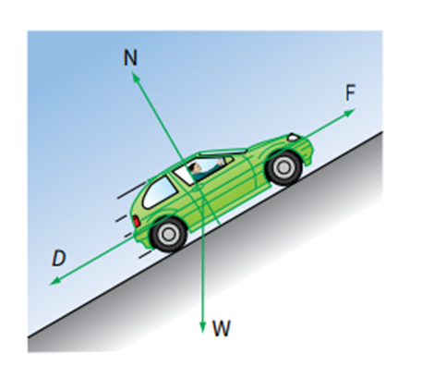

You should recall that a vector quantity has both magnitude and direction. An object may have two or more forces acting on it, and since these are vectors, we must use vector addition to find their combined effect.

There are several forces acting on the car as it struggles up the steep hill. They are:

its weight W (= mg)

the contact force N of the road (its normal reaction)

air resistance D

the forward force F is caused by friction between the car tires and the road.

If we knew the magnitude and direction of each of these forces, we could work out their combined effect on the car. Will it accelerate up the hill? Or will it slide backward down the hill?

Consider another example: a falling tennis ball may be acted on by two forces: its weight mg, downwards, and air resistance D. The resultant force is then:

Resultant force = mg − D = 1.0 − 0.2 = 0.8 N

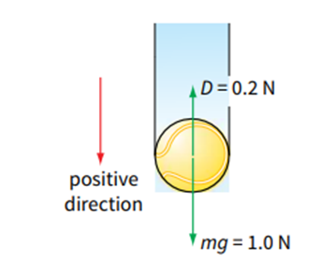

When adding two or more forces that act in a straight line, we have to take account of their directions. A force may be positive or negative; we adopt a sign convention to help us decide which. If you apply a sign convention correctly, the sign of your final answer will tell you the direction of the resultant force (and hence acceleration)

**Reference**

Ksokos, A. K. (2008). *Physics for the IB Diploma*. (5th ed.). Cambridge University Press.

Sand, D. (2014). *Cambridge IGCSE Physics Coursebook* (2nd ed). Cambridge University Press