Alpha Academy

CAPE Unit 1

**PHYSICS**

SCHOOL-BASED ASSESSMENT

Laboratory Manual

**Table of Contents**

**Quality of Measurements** 4

**Significant Figures/Digits** 4

**Rules of Illustration** 5

**Diagrams** 5

**Tables** 5

**Graphs** 5

**Typical Format of a Laboratory Report** 7

Lab 1: Introductory Experiment 8

Lab 2: AI Measurement and Uncertainties 10

Lab 3: P&D - Terminal Velocity 11

Lab 4: Linear Motion 12

Lab 5: Young’s Modulus 14

Lab 6: Archimedes’ Principle 16

Lab 7: Plane Reflection & Refraction 19

Lab 8: Vertical Oscillations of a Spring-Mass System 22

Lab 9: Properties of a Wave on a String 25

Lab 10: Vital Capacity of The Lungs 29

Lab 11: Thermal Energy 31

Lab 12: Young’s Double Slit 33

Lab 13: Centre of Gravity 35

Lab 14: Circular Motion 37

Lab 15: P&D - Forces and Deformation 40

# Quality of Measurements

**Source of error:** state the likely cause of error while using a named instrument. E.g.

1. *Zero error* could arise if the edge of the … is worn. If the … does not give a reading of zero when not in use/empty/the jaws are closed *zero error* could occur.
2. *Parallax error* could arise if the … is not read squarely/at right angle to the scale.
3. *Reaction time error* could occur due to delay in starting or stopping the ….

**Precaution:** state what was/should be done to improve safety and/or accuracy

1. Say what was/should be done to avoid (lower) a named danger (risk). E.g.

Safety … should be worn to protect the eyes from …. Insulated gloves were worn to avoid being burnt/shocked by the ….

1. Say what strategy was/could be used to reduce a named error. E.g. To reduce parallax error, hold the … vertical and read it at eye level. While reading the …, align the needle with its reflection in the mirror to minimise parallax error.

**Assumption**: state any significant condition (value) that was used in the activity (calculation).

1. The value of … was taken to be exactly ….
2. The … was assumed to be pure/negligible.
3. It was assumed that the … limit was not exceeded.

**Limitation:** state how a named unavoidable issue could upset the experiment.

1. The friction/wind/air resistance/temperature of the surrounding could have …
2. The … size, range, resolution of the instrument was too … and so it could not ….

**Significant Figures/Digits**

Using significant figures (s.f.) is a simple way to indicate the quality of a measurement.

1. All digits are significant EXCEPT zeros at the front of a decimal or back of a whole number. (0.03, 3000, 30., 0.0034, 343, 30403, 343.000: *underlined digits are significant*)
2. When in doubt use the scientific notation. (4 s.f.: 3.430 x 104 or 4.000 x 106)
3. Counts (number of trials) and constants (*g*, 𝛑) have infinite numbers of significant figures and so don't affect the quality of measurements.

**Accuracy** refers to the closeness of a measurement to the accepted value. **Precision** refers to the number of decimal places (d.p.) in a measurement.

**TESTS**: If you fail, consider choosing a different subject! (Pass mark = 80%)

* <http://antoine.frostburg.edu/chem/senese/101/measurement/sigfig-quiz.shtml>
* <http://www.sciencegeek.net/APchemistry/APtaters/chap02counting.htm>

**Rules of Illustration**

**Diagrams**

* Draw all diagrams to at least ⅓ of the page using a sharp **pencil**.
* Label horizontally in **script** using **lower case** text (unless it’s a proper noun).
* Write a suitable **title below** the diagram. E.g. Parts of a micrometer

**Tables**

* Write a suitable **title above** the table. E.g. Changes in temperature of … over time.
* Draw an **enclosed** (boxed-in) table.
* Write **headings with units**, where applicable, for each column/row.
* Write the independent variable (**IV**) in the first column/row and the dependent variable (**DV**) in the second row.
* Use the same precision (number of d.p.) for all values measured by the same instrument.

**Graphs**

A graph is a diagram that makes it easy to recognise trends and patterns.

* Write the **DV** on the y-axis (except time) and the **IV** on the x-axis (**DRyMIx**). Label the axes based on the headings in the results table and include the units.
* Write the *title* at the top. E.g., Graph of ‘y-label’ against ‘x-label’.
* Choose a **scale** that allows the graph to fill at least ⅔ of the page. Use the lowest and highest values to determine the scale. E.g., if a set of results range from 1.2 to 8.4, the scale could go from 0 to 10. Choose intervals such as 1, 2, 5 (x 10N) when you can.
* Write the scale for each axis in the legend. E.g., y-axis, 2 cm:1 m; x-axis, 1 cm:10 °C.
* For a line graph, plot each point with **🞩** or . For bar graph, draw a 1 cm line.
* The trend of the data should be shown by a smooth line – the **line of best fit**. The line of best fit does not always pass through every point. It avoids **anomalous** points and gives the best estimate for the gradient. It reduces the effect of zero error and random errors.
* If the line of best fit is straight, its gradient can be found by drawing a right-angled triangle that covers at least ½ of the line. If the straight line passes through the origin, it indicates that the **DV** is **directly proportional** to the **IV**.

**NB**: For line graph: use the **SPLAT** check. (**S** = scales, linear and largest; **P** = plot with 🞪 or ; **L** = line of best fit smooth; **A** = axes with labels; **T** = title).

For bar graph: use the **BATS** check. (**B** = bars, neat with equal width and spacing; **A** = axes with labels; **T** = title; **S** = scales, linear and largest).

# Typical Format of a Laboratory Report

**Experiment Number:** **Date:**

**Title:** This is the name of the experiment. The title should be straight form forward, informative and less than ten words

**Aim:** This is a statement of the goal or purpose of the experiment **Variables:** Manipulating Variable:

Responding Variable

Constant Variable

**Apparatus:** This is a list of the materials and equipment used **Diagram:** Simple line diagram of how apparatus is set up

**Procedure:** Outline of the steps taken in the experiment. The method should be described in the order of what actually happened. It should be written in THIRD PERSON AND IN PAST TENSE. [No personal pronouns should be used]

**Results/Observations:** Here the results are presented in TABULAR FORMAT and a title should be written above the table. If a graph needs to be plotted, it should be opposite this table

**Data Analysis:** This includes calculations and explanations to any questions about the experiment

**Errors:** These are unavoidable mistakes which occurred either on the part of the experimenter or the instrument itself

**Precautions:** These are steps taken to reduce the errors caused during the experiment

**Conclusion:** This is generally very short. It is a simple statement of what you know now for sure as a result of the lab

# Lab 1: Introductory Experiment

**Aim:** To learn the techniques of writing up a UWI Physics Lab:

a) Constructing a complete table.

b) Plotting any given data in a straight line.

c) Extract useful information from any given straight line graph.

d) Manipulating equations

**Introduction**

The instructor will explain briefly the Lab Guidelines and the Safety Regulations, as well as what is expected of the students in regards to the Physics lab sessions.

**Procedure**

1. The demonstrator will show you how the readings in this experiment were obtained. Observe and record the procedure. Take special note of any precautions and possible sources of error.

2. Use the results from Table 1 for varying depths of solution and tabulate your results neatly, including recording your readings in SI units.

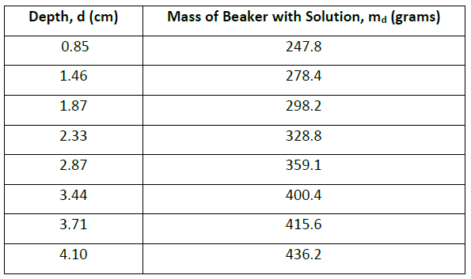

*Mass of empty beaker = 193.1 grams*

*Internal diameter of beaker = 8.64 cm* 2

3.Plot a graph of *md* versus *d*. Draw the **line of “best fit”** to your points i.e. your line goes through as many points as possible & the left over points are evenly distributed on both sides of the line.

Ensure that you can read the y-intercept from the graph.

4. **Show that**

𝑚𝑑=(𝐴𝑑)𝜌+𝑚𝑏

where, A = internal cross-sectional area of the solution (beaker)

ρ = density of solution

𝑚𝑏 = mass of empty beaker

𝑚𝑑 = mass of beaker with liquid

d = depth of the liquid

5. Determine the slope of the graph and hence, using the density of the solution as 1000kgm-3, calculate the average internal cross-sectional area A of the beaker. Measure the internal diameter of the beaker with the calipers and compare the area A to the calculated value.

6. Also, determine the mass of the empty beaker, m*b,* from your graph and compare it with that obtained using the balance.

7. Comment on your results.

**MARK ALLOCATION**

**Exp. 1 – Introductory Experiment**

Table – 2

Graph – 2

Calculations – 3

Discussion – 3

# Lab 2: AI Measurement and Uncertainties

**Apparatus:** Vernier calipers, micrometer screw gauge, 30cm ruler, 5 coins, set, square, top-pan balance

**Procedure**

1. Use the 30cm ruler to measure the diameter once of one of your 10 cent coins. Make an estimate of how uncertain you are of your value ( e.g. a too large estimate would be . Note your answer should be expressed like the following:

: the diameter of the 10oin measured with a 30cm ruler was 56

1. Now use the Vernier caliper to measure the diameter once of the same coin.
2. Now place all five coins in a row and use the ruler to measure distance 5d as shown in the diagram below. You should find a way of making use of the set-square here
3. From your readings obtain another value for the diameter and the uncertainty of one coin.
4. Which of the above measurements of the diameter of the coin is best (part 1,2,3)?
5. Explain how taking more measurements in stages 1&2 would help?
6. Use the best methods possible to obtain a value for the
7. Thickness of a coin
8. Mass of a coin
9. Calculate the density of the coin
10. Explain how you obtained your measurements for the thickness and mass.
11. Estimate the uncertainty in your density value

# Lab 3: P&D - Terminal Velocity

When a paper falls through the air, it quickly reaches terminal velocity. The drag force, D on the paper is given by D=

Where the density if air is 1.2, v terminal velocity and A is the cross-sectional area of the base of the cake-case; f is a number (having no units) called the shape factor. Regardless of their size, paper always have the same shape factor, even when several are stacked together.

Design an experiment to determine the shape factor for falling paper. You should assume that the normal laboratory apparatus sued in schools and college is available to you.

No diagram will be required.

You should also include the following in your answer

* The quantities you intend to measure and how you will measure them
* How you propose to use your measurement to determine a reliable result for the shape factor
* The factors you will need to control and how you will do this
* How you could overcome any difficulties in obtaining reliable results

# Lab 4: **Linear Motion**

**Aim:** To investigate the dependence of the displacement s and the velocity v' on time '' when an object moves along a straight line with a constant acceleration a

**Apparatus:**

Wooden plank with a smooth groove down the middle. When the plank is tilted, a small spherical object like a marble can roll down with constant acceleration. The time taken for any displacement is measured using a stopwatch.

**Theory:**

When an object moves with the constant acceleration 'a' along a straight line, the  
distance 's' travelled in time 't' is given by:  
s=ut (1)  
   
Where 'u' is the velocity at time t 0, i.e. the initial velocity. The velocity 'v' of the  
object at any time 't' is given by  
 v=u+ at (2)

If the object starts from rest, i.e. ifu-0, then the equations (1) and (2) simplify to  
s= (3)

and v = at (4)

**Procedure:**

Ensure both the sphere and the groove is clear of dust and any other debris.  
Prop up the plank so that the sphere takes around ( ) to ( ) travel from the top to the bottom.

After this, do not change the prop for the duration of the experiment, so that the tilt of plank remains the same throughout your experiment.

Determine the time it takes for the sphere to roll from the top to the bottom of the plank. Measure the distance travelled. Repeat for various distances.

1. Tabulate your results. Include values of in your table.
2. Using equation (3), predict the shape of your graph when's' is plotted against
3. Verify your prediction by plotting your data. Include the s=0 point.
4. Again using equation (3) predict the shape of the graph when's' is plotted along  
   the y-axis vs. t. Verify your prediction by plotting your data. Include the point s=0
5. In your second graph, draw tangential lines at around 5 different values of t. In  
   doing this, great caution is needed.
6. What do these slopes mean?
7. Determine the slope of these 6 tangential lines and call them vi=0 at t-0 and v2
8. Using equation 4, predict the shape of the plot when v is plotted along the y-axis against t
9. Verify your prediction by plotting your data.

Results

Table

|  |  |  |
| --- | --- | --- |
| Distance | Time | of |

Tasks :

1. Prediction of shape of graph of s vs of
2. Prediction of shape of s vs t
3. Meaning of slope
4. Gradient of graphs
5. Prediction of shape v vs t

# Lab 5: Young’s Modulus

**Aim:** In this lab, you will investigate how the period of oscillation of a loaded steel blade varies with the length of the blade and use the results of your experiment to determine a value for the young modulus of steel

**Method**

1. Use a G-Clamp and the small blocks of wood to clamp the steel blade to the bench as shown. The blade has two small 50g masses attached to one end. You should not disturb the position of these masses during the course of the experiment

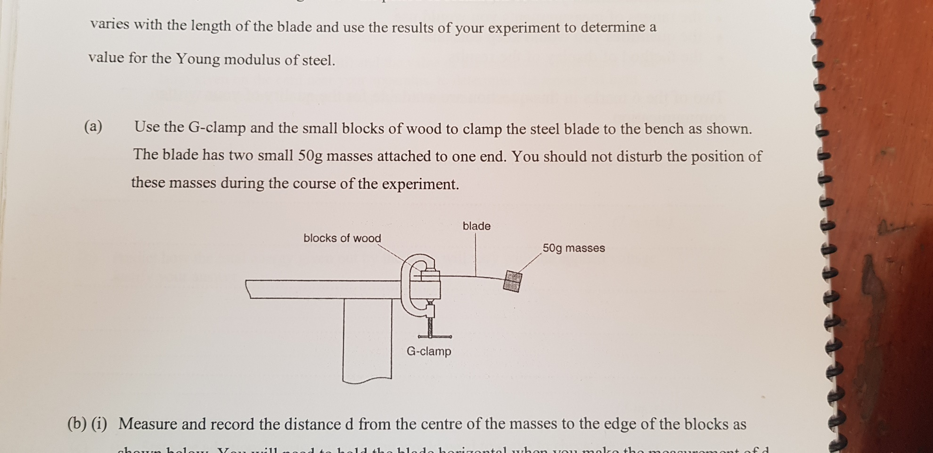

1. Measure and record the distance d from the centre of the masses to the edge of the blocks as shown below. You will need to hold the blade horizontal when you make the measurement of d.

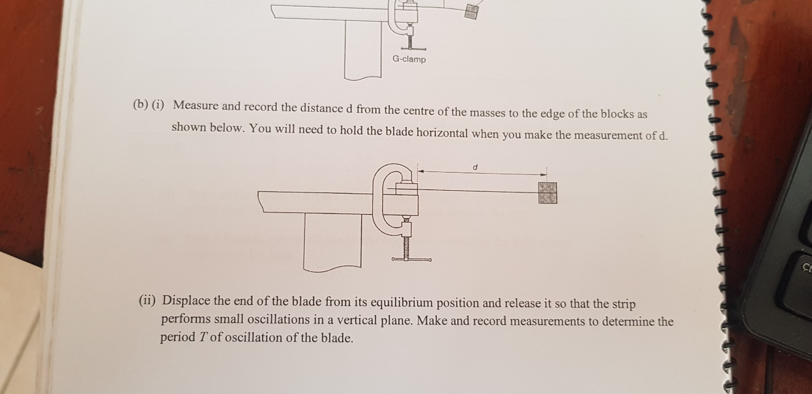

1. Displace the end of the blade from its equilibrium position and release it so that the strip performs small oscillations in a vertical plane. Make and record measurements to determine the period T of the oscillation of the blade.
2. Change the value of d and repeat B and C until you have six sets of reading of distance d and the period T for values of d in the rang 0.13m<d<0.25m
3. Include in your table of results all six sets of values for log(T/s) and log(d/m)

|  |  |  |  |  |  |  |
| --- | --- | --- | --- | --- | --- | --- |
| D | t1 | t2 | tavg | T | LogT | Log(d) |

* + Plot a graph of log (T) vs log(d)’
  + Draw best fit line
  + Determine the gradient and the y intercept of this line

1. Theory suggests that T and d are related by a simple power law of the form where n and k are constants.

Use your answers from d(ii) to find the values of n and k. you need not be concerned with the units of these quantities.

1. A theoretical treatment of this oscillator suggests that

Where M is the mass attached to the end of the blade , E is the young modulus, b is the width of the blade and t is the thickness of the blade as shown

1. Measure the values of b and t the measurement of t should be made on a part of the blade where there is no tape.
2. Estimate the percentage uncertainty in the value of
3. Determine a value for E. include an appropriate unit.

# Lab 6: Archimedes’ Principle

**Aim**: To determine the up thrust on an object totally immersed in water.

The balance you will use, illustrated in Fig. 1, consists of a metre rule suspended by a thread from a retort stand and clamp.

**Method**: First, adjust the position of the thread on the rule so that it balances horizontally on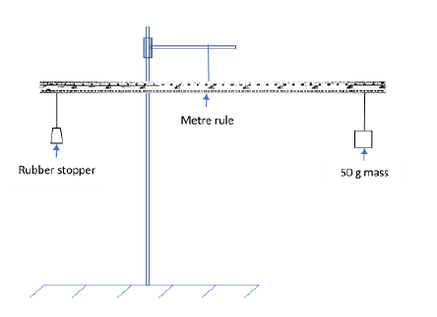 its own with no other masses suspended. Record the position of the thread.

Take the RUBBER stopper provided and suspend it by a thread close to one end of the metre rule. Now balance the rule by suspending a 100g mass by a thread on the other side of the rule. The rule should be horizontal when balanced. Record the point of suspension of the 100g mass.

When the rule is balanced, the principle of moments states that the sum of the moments of forces about the point of suspension in the clockwise direction is equal to the sum of the moments in the anticlockwise direction.

Draw a diagram indicating forces acting on the rule. Write an equation for the balance of the moments of the forces. Hence, determine the mass of the stopper.

**Q.1 Why balance the metre rule with nothing suspended at the start?**

Leaving the stopper suspended from the same point, place a beaker of water below the stopper and arrange it so that the stopper is completely immersed in water. Now find a new position for suspension of the 100 g mass so that the rule is again balanced. Be careful to see that the stopper does not touch the edge or bottom of the beaker. All the results should be carefully tabulated.

From the above readings calculate the “apparent weight” of the stopper while it was immersed in water. The loss of weight is due to the upthrust of the water or “buoyancy force”. Archimedes Principle shows that: upthrust = weight in air – apparent weight in water (assuming air gives negligible upthrust). Thus, find the upthrust on the stopper.

**Q.2 Does it matter how far below the surface of the water you immerse the stopper, providing you do not touch the bottom? Why?**

1. **Determination of upthrust on an object floating in water**

Place the CORK stopper provided in a beaker of water. Note that since the cork is floating it is only partially immersed.

**Q.3 What must the relation be between the upthrust on the stopper and its weight? What is this upthrust in your case? You may use the commercial balance to determine the mass of the cork.**

1. **Determination of the weight of water displaced by the rubber and cork stoppers**

For these measurements a displacement measuring vessel (d.m.v.) is used. Place the d.m.v. on the shelf over the sink. Fill it with water until water runs out of the spout into the sink. Wait a minute or so until the water has stopped draining from the spout then place an empty beaker under the spout and carefully lower the rubber stopper into the displacement measuring vessel (d.m.v). Find the weight of the displaced water collected in the beaker. Again, wait until the water has completely stopped draining from the spout. Repeat the above procedure with the cork and find the weight of water displaced by the floating cork in the beaker.

Compare the weights of displaced water with the upthrust found in the corresponding cases in A and B above.

# Lab 7: Plane Reflection & Refraction

**Aim:** To investigate reflection and refraction at plane surfaces.

**Apparatus**: mirror, 4 pins, glass block, white paper

**Procedure:**

**1. Reflection at a Plane Surface**

1. Place a sheet of plain paper on the drawing board with the mirror positioned near the centre of the paper.
2. Outline the front surface of the mirror with a pencil and stick a pin *A* at a point 8 cm from the mirror. This pin is the object.
3. Rays of light from *A* are reflected by the mirror in such a way that they appear to be coming from *A'*, the image of *A*. (Since the rays do not actually originate from *A'*, the image is virtual.)

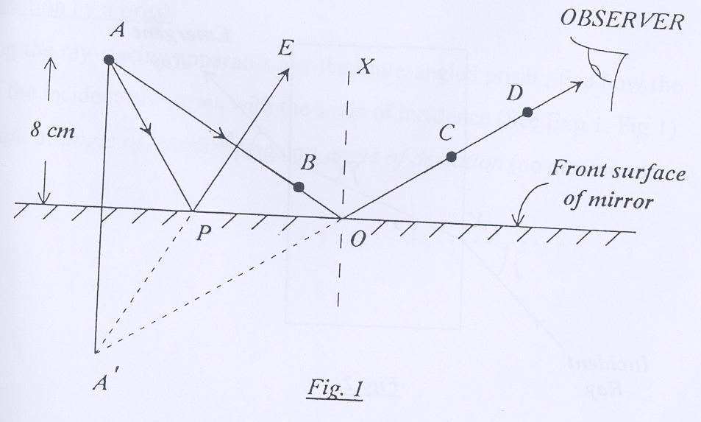

1. Place a second pin *B* near to the mirror such that the rays from A passing through this point strike the mirror at an angle of about 45o (Fig.).

1. The corresponding reflected ray may now be found by looking at the images *A* and *B* in the mirror and placing two locating pins *C* and *D* so that all four appear to be in line.

1. Mark the positions of the pins and join *AB* and *CD* to meet at the surface of the mirror as in Fig.1.

1. The angle *AOX* is the “angle of incidence” and *XOD* is the “angle of reflection”.
2. Measure these two angles and compare them.
3. Trace another ray *APE* in exactly the same way, this time with an angle of incidence of about 30o. Both reflected rays, *PE* and *OD*, appear to originate at the same point (the image) behind the mirror. Extend *EP* and *DO* to find *A'*. Q.1. Where is A*'* in relation to A?

2. **Snell’s Law**

1. Set up the ray-tracing apparatus on the drawing board such that a single thin ray is easily visible on the board.
2. Place a sheet of plain paper on the board with the rectangular glass block at the centre of the paper.
3. Using a pencil, draw an outline of the block on the paper and mark an *X* on the paper near the mid-point on one of the long sides.
4. Now arrange the block and paper such that the ray is incident on the block, striking it at the *X*, with the angle *i* in Fig.2 being approximately 30o.
5. Mark two points on the incident ray and two points on the emerging ray; remove the block and trace the path of the ray of light as in Fig.2.

Q.2 What simple relationship exists between the incident and emerging rays?

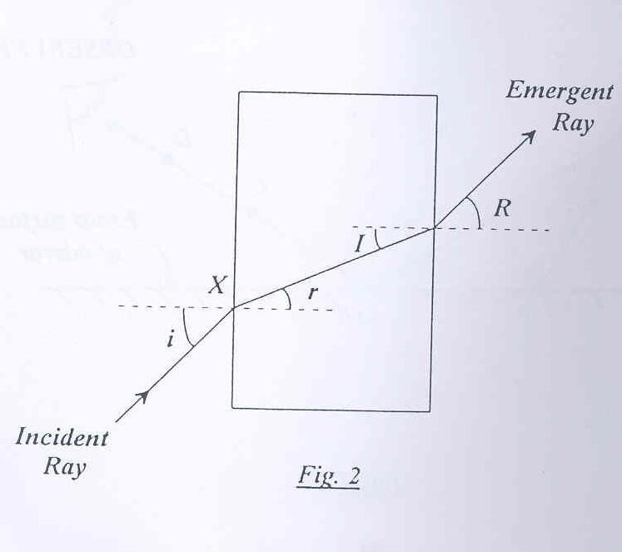

In Fig. 2, *‘i’*  is the “angle of incidence” and ‘*r’* is the “angle of refraction”. Measure and record your values for *i* and *r*. Repeat this procedure for seven different values of *i* between 10o and 60o. (Rotate the block and paper together to vary *i*.) The refractive index of glass n is given by Snell’s Law as *n=*

Plot your data suitably so as to get a straight line. Determine n from your graph.

3. **The Critical Angle**

Consider the refraction of the ray in Fig. 2 when passing from glass to air. The angle of refraction *r* is always larger than the angle of incidence *i* and, for a certain value of *i, r* will equal 90o and no ray will emerge from the block. This angle of incidence is known as the “critical angle”.

Q.3 What happens to rays incident at angles greater than the critical angle?

4.  **Real and Apparent Depths**

When an object is immersed in water or glass it appears to be closer to the surface of the medium than it really is. If reasonably small angles of incidence are involved, the refractive index n of the medium is given, to a good approximation, by:

n = real depth/apparent depth

This situation is readily reproduced by sticking an optical pin *A* (the object) right against the rectangular glass block as in Fig.3 and viewing it from the far side. To find the apparent depth of the pin you must now locate the image *A’.*

4.1. Outline the edges of the block in pencil.

4.2. Place a second pin *B* close to the other side of the block and about 2 *cm* to one side of a perpendicular line from *A*.

4.3. Looking through the glass at *A'*, place a third pin *C* such that *A',* *B* and *C* appear to be in line.

4.4. Repeat this procedure on the other side of the perpendicular with pins *D* and *E*, as in Fig.3.

4.5. Measure the real depth *OA* and the apparent depth *OA'* and hence calculate *n.*

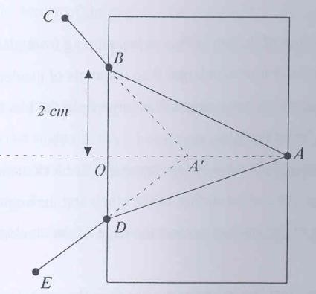

Fig. 3

# Lab 8: Vertical Oscillations of a Spring-Mass System

**Aim**

To investigate Simple Harmonic Motion in the ‘small amplitude’ oscillations of a spring-mass system

**Apparatus**

Retort stand, 2 identical spiral springs, masses, and stopwatch.

**Theory**

Simple harmonic motion (SHM) results when a body displaced from its equilibrium position is acted on by a restoring force, *F*, that is always proportional and in the opposite direction to its displacement from that equilibrium position.

A simple harmonic oscillator consists of a mass attached to one end of a spring. The other end of the spring is attached to a rigid support. When the mass is displaced, by a small distance, from the equilibrium position, the restoring force exerted by the spring is given by

(1)

where *x* is displacement and *k* is the spring constant.

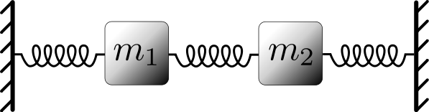

*mg*

*F = -kx*

**Figure 1**

From Newton’s Second Law we know that,

(2)

Where *m* is the mass and *a* is the acceleration

Equating equation (1) and equation (2) we get,

(3)

SHM is defined by

(4)

From this we can see that

(5)

The time taken to complete one oscillation, the period, *T*, is given by

(6)

By substituting equation (5) into equation (6) we get an expression for the period of a spring-mass system,

(7)

Writing equation (1) in the form :

(8)

If we plot *T2* along the y-axis and the *m* along the x-axis, we will get a straight line, with

(9)

**Procedure**

1. Suspend a spring from the retort stand and hang a mass, *m*, of 200 grams from it.
2. Give the spring-mass system a small vertical displacement and record the time taken *t* for 20 oscillations.
3. Calculate the period of oscillation *T*.
4. Repeat for 7 other values of mass.
5. Tabulate your results neatly, using SI units.
6. Plot a graph of *T2* vs *m*.
7. Find the gradient of the graph and hence find the value of the spring constant, *k*.

Note: Do not leave masses idly suspended on the spring.

|  |  |  |  |  |
| --- | --- | --- | --- | --- |
| **Run** | **Mass**  **( )** | **Time for 20 Oscillations, t20**  **( )** | **Period, T**  **( )** | **T2**  **( )** |
| 1 |  |  |  |  |
| 2 |  |  |  |  |
| 3 |  |  |  |  |
| 4 |  |  |  |  |
| 5 |  |  |  |  |
| 6 |  |  |  |  |
| 7 |  |  |  |  |
| 8 |  |  |  |  |

Qn.1 Suppose this experiment is done on the Moon, where the acceleration due to gravity gm is one sixth of that on the Earth. Giving appropriate reasons, comment on the value of k on the Moon.

Qn.2 In plotting the data, suppose we want to plot *T* along the y-axis. Analysing equation (7), explain what we should plot along the x-axis in this case, so as to get a straight line. What does the slope of this graph give?

1. Suspend the 2 springs in series from the retort stand and hang a mass, *m*, from it.
2. Determine the time for 20 oscillations, *t20*, and hence the period *T*.
3. Using equation (8), determine the value, *ks* , of the 2 springs in series.
4. Repeat steps 8-10 with the 2 springs in parallel and obtain, *kp*.

Qn.3 Show that:

Qn.4 Using this, deduce the way to calculate the effective spring constant when 2 springs, with spring constants *k1* and *k2*, are added:

1. in series
2. in parallel.

# Lab 9: Properties of a Wave on a String

**Aim**

To explore the following for a wave on a string:

1. Frequency, Wavelength, and Wave Speed
2. Reflection
3. Superposition
4. Damping

**Apparatus**

Computer simulation: Phet – Wave on a String

**Procedure**

*Before we begin, let us learn the use/function of the various control buttons of the simulation. Try the ‘Rulers’, ‘Timer’ and ‘Reference Line’ options located on the bottom right of the window. Note that the rulers can be dragged around the window. Next, try each of the 3 options at the top left of the window: ‘Manual’, ‘Oscillate’ and ‘Pulse’ along with the 3 options at the top right of the window: ‘Fixed End’, ‘Loose End’ and ‘No End’. Finally, learn the use of the following buttons at the bottom: ‘Reset’ and ‘Pause/Play’. When you click the Pause button, the Step button appears, which allows you to analyse things one step at a time.*

Fundamentals of Wave Motion

* + 1. Select ‘Oscillate’ and ‘No End’ from the options at the top of the window.
    2. At the bottom of the window, set the Amplitude to *0.75 cm*, Frequency to *1.50 Hz*, Damping meter to ‘None’ and Tension meter to ‘High’.
    3. Click the Play button.

You will see a wave moving from the left to the right. When you are ready to record a measurement, click the Pause button.

* + 1. Use the Step button to position the crest of the wave at a convenient point.
    2. Using the Rulers and the Timer, analyse the wave and determine the following, in both magnitude and unit:

1. Amplitude, A =
2. Wavelength , λ =
3. Period, T *= time for a peak to travel a distance of λ =*
4. Frequency, f =  =
5. Wave speed, v (measured) =  =
6. Wave speed, v (calculated) = *f* λ =

Reflection

1. Select ‘Pulse’ and ‘Fixed End’ from the options at the top of the window.
2. Set the Amplitude to *0.75 cm* Damping meter to ‘None’.
3. Click the green button Pulse (located above Amplitude) once to get a triangular pulse and observe what happens at the fixed end on the right.
4. Answer the following questions, based on your observation:
5. Does the reflection change the speed or amplitude of the wave pulse?
6. Is the wave pulse reflected with the same orientation that it had originally, or is it inverted?
7. Now, change the setting from ‘Fixed End’ to ‘Loose End’ then send a pulse along the string. Observe what happens at the Loose End.
8. Answer the following questions, based on your observation:
9. Does the reflection change the speed or amplitude of the wave pulse?
10. Is the wave pulse reflected with the same orientation that it had originally, or is it inverted?

Superposition

In this exercise, you will explore what happens when two wave pulses superpose (add together).

1. Choose ‘Pulse’ and ‘Loose End’ from the options at the top of the window.
2. Set the Amplitude to *0.75 cm*, Pulse Width to *0.50 s* and the Damping meter to ‘None’.
3. Click the green button Pulse once then immediately press the Pause button.
4. Click the green button Pulse again.
5. Now, you will see 2 pulses. When they are about to meet, click the Pause button.
6. Using the Step button, analyse what happens ***when the two pulses just overlap.***
7. Answer the following questions, based on your observation:
8. What is the amplitude of the resultant pulse when both the pulses have the same orientation?

Higher Smaller Almost zero

1. What is the amplitude of the resultant pulse when both the pulses have the opposite orientation?

Higher Smaller Almost zero

1. Repeat the above exercise, with the first pulse’s amplitude at *0.75 cm* and the second pulse’s amplitude at *1.00 cm*.
2. Answer the following questions, based on your observation:
3. What is the amplitude of the resultant pulse when both the pulses have the same orientation?

Higher Smaller Almost zero

1. What is the amplitude of the resultant pulse when both the pulses have the opposite orientation?

Higher Smaller Almost zero

Effect of Damping

So far, Damping remained at zero (none). What happens when it is not zero?

1. Select the ‘Oscillate’ and ‘No End’ from the options at the top of the window.
2. Set the Amplitude to *1.00 cm*, Frequency to *0.75 Hz* and Tension meter to ‘Low’.
3. Observe the effect of damping for Damping values of 0, 20, 50 and 100.

Quantitatively, in the presence of damping, the amplitude of the wave decreases with time as:

(1)

where,

*Ao* is the initial amplitude (at *t = 0*)

*λ* is a constant

Plotting A versus *t* will give an exponential decay curve; it would not be a straight line!

However, By manipulating equation (1), we can express it as:

(2)

(3)

Rearranging, we get:

(4)

To investigate this exponential decay, set Damping to 30.

1. Press the Play button.
2. When you see that the wave has progressed all the way to the No End side, press the Pause button.
3. Use the Step button until the green spot above the oscillator shaft is at its maximum height, *Ao*.
4. You can now measure the amplitudes of 5 crest values and 4 trough values using the moveable rulers.

*Note that these are separated in time by T/2, where T is the period of the wave i.e., the time taken by a peak to travel one wavelength.*

1. Tabulate your data neatly in the table below.
2. Plot a graph of ln A vs t.
3. Obtain the value of λ from the graph.

|  |  |  |  |
| --- | --- | --- | --- |
| Run | Time, t  (seconds) | Amplitude, A  (cm) | ln A |
| 1 |  |  |  |
| 2 |  |  |  |
| 3 |  |  |  |
| 4 |  |  |  |
| 5 |  |  |  |
| 6 |  |  |  |
| 7 |  |  |  |
| 8 |  |  |  |
| 9 |  |  |  |

# Lab 10: Vital Capacity of The Lungs

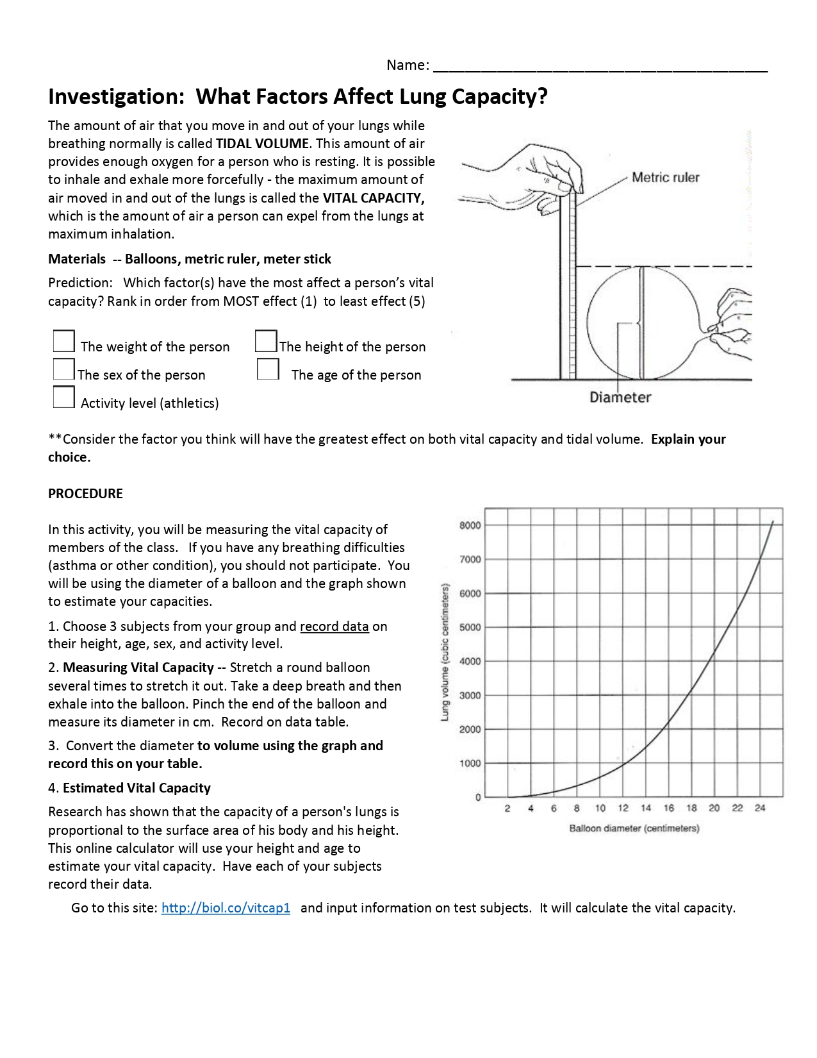

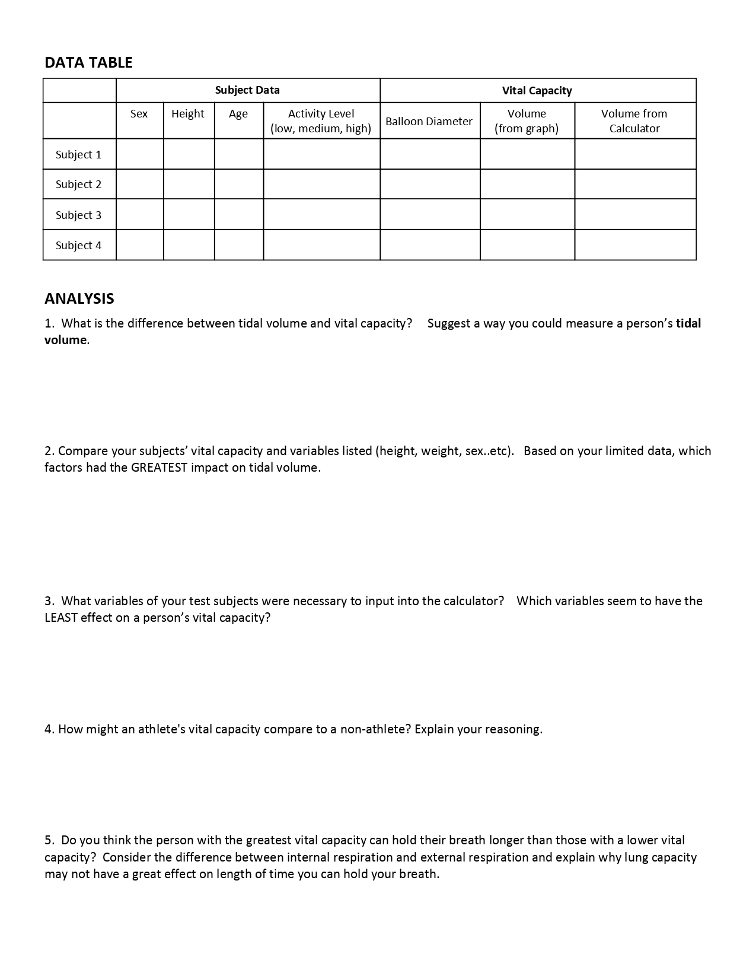

# Lab 11: Thermal Energy

**Aim:** To investigate heat transfer via convection and radiation.

**Apparatus:** Glass bottles, small plastic cards, thermometers, power supply, bulbs, metal cans, Styrofoam covers, food colouring, fluorescein solution, stopwatch

**Theory:**

Heat transfer refers to the exchange of thermal energy from one physical system to another. Examples of heat transfer are conduction, which usually occurs in solids, convection, which usually occurs in fluids and thermal radiation through electromagnetic waves.

Radiation:

Radiation is the transfer of energy via electromagnetic waves. When these waves hit an object, they can either be reflected from the object as is the case with metallic or white objects, or they can be absorbed into the object as with objects of darker or dull colours. Therefore, different objects absorb thermal radiation at different rates. Lighter or metallic colours will absorb less and darker colours will absorb more.

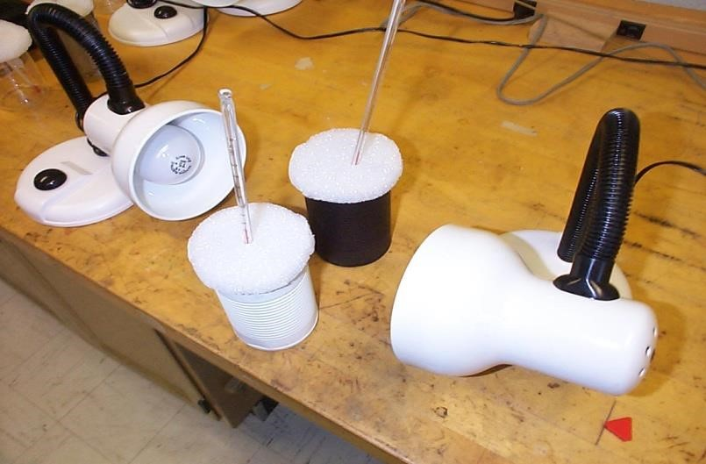

Figure 2. Placement of cans for radiation experiment

This absorption of energy may be quantified by measuring the relative temperature increases for different objects which are exposed to the same electromagnetic radiation and then comparing the temperatures. The object which has a higher temperature gain has absorbed more radiation energy than the object with lesser increase in temperature.

**Procedure:**

**Part** **2. Radiation**

1. Measure the mass of the each empty can.
2. Pour the same amount of water in each of the two cans (about 200 ml).
3. Measure the new mass of the cans, hence determine the mass of the water in each can.
4. Put the thermometer in, and place the cans in front of the lamps as shown in Figure 2.
5. Measure and record the original temperature. The initial temperatures of the liquids should be the same.
6. Turn on the lamps and start the stopwatch. Approximately every 2 minutes, read the temperature as well as the **exact** elapsed time. After 20 minutes stop the experiment.
7. **On the same graph sheet**, plot temperatures vs. time for both cans. (*Make sure to distinguish which data point came from which container!)*

**Qn. 1.** What can you say about the energy absorbed by both cans from the graphs?

**Qn. 2.** What are the main sources of error in the experiment?

**Qn. 3.** What could be attributed to the curvature at higher temperatures?

1. Draw the line of best fit for the straight part of the graphs.

Calculate the gradient of the lines.

# Lab 12: Young’s Double Slit

**Purpose:** To investigate the fringe patterns produced by double slit interference.

**Apparatus:** Helium neon Gas laser, slit array

**PRECAUTION: Do not look into the laser bean or point it towards anyone. The beam, or even its reflection off glass, can damage the eye.**

**THEORY:** *Interference and Diffraction* are discussed in Ch36 Halliday, Resnick & Walker

In this experiment we study the interference and/or diffraction patterns produced when collimated, monochromatic light (i.e. laser light) passes through various arrangements of apertures, and are observed on a viewing screen. When the apertures/slits are sufficiently small, the light intensity on the viewing screen exhibits variations (successive maxima and minima) which depend upon the wavelength of the light and the size and number of the apertures. The existence of the patterns is confirmation of the wave nature of light.

**Double Slit Interference**

A schematic of the double slit interference apparatus is shown in Figure 3. Waves from slits S1 and S2 combine at P an arbitrary point on the screen, to produce the interference pattern.

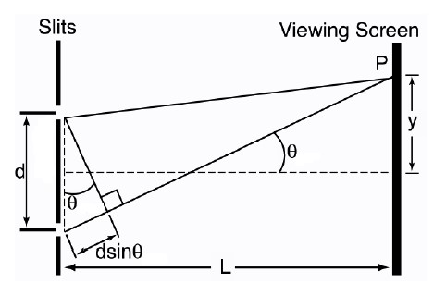

**S**

**1**



**S**

**2**



**r**

**1**



**r**

**2**



**b**

The path difference between the waves (*r1* and *r2*) is *S1b*. The condition for a maximum intensity at P is: *d Sin θ = mλ*

The condition for a minimum intensity at p is:

*d Sin θ = (m+ ½ ) λ*

where d = the centre to centre distance between the slits.

It can also be shown (see text) that add equation__________(3)

where *x* = the average separation between the fringes in the double slit interference pattern.

**METHOD:**

**Note:** *The Helium-Neon gas laser is a delicate and expensive piece of equipment. Please handle it with care. Do not switch the laser on and off repeatedly during the experiment. It is better for the laser if it is left on for the entire experiment.*

The laser has a wavelength of 632.8 nm.

1. Direct the laser beam through the double slits and observe the interference pattern on a sheet of paper placed a distance, *L* , approximately 2 metres from the slits.
2. Mark the position of the interference fringes on the paper. Remove the paper and from your markings calculate the average fringe separation *x*.
3. Measure the distance *L* to the screen.
4. Use the relationship to calculate *d* for the double slits.
5. Also sketch the intensity distribution for the interference pattern produced by slits.
6. Finally, measure *d* using the traveling microscope provided.
7. Discuss your results.

# Lab 13: Centre of Gravity

**Aim:** In this experiment, you will determine the radius of a semi-circular card.

**Apparatus:** You are provided with the following items. A semicircular card, A pair of scissors, a ruler, a pin, a retort stand, a boss and clamp, a small attached to a thread, with a loop and a protractor

1. 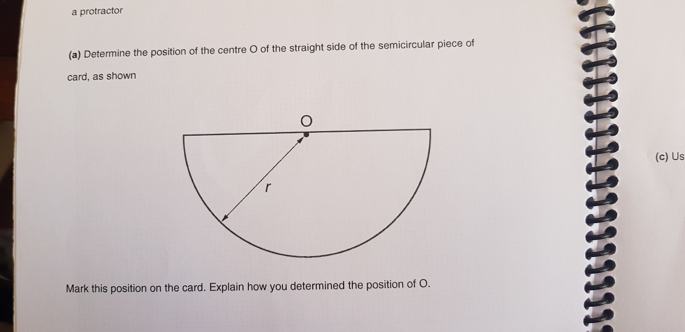Determine the position of the centre o of the straight side of the semicircular piece of card shown below

* Mark this position on the card. Explain how you determine the position of O.

1. 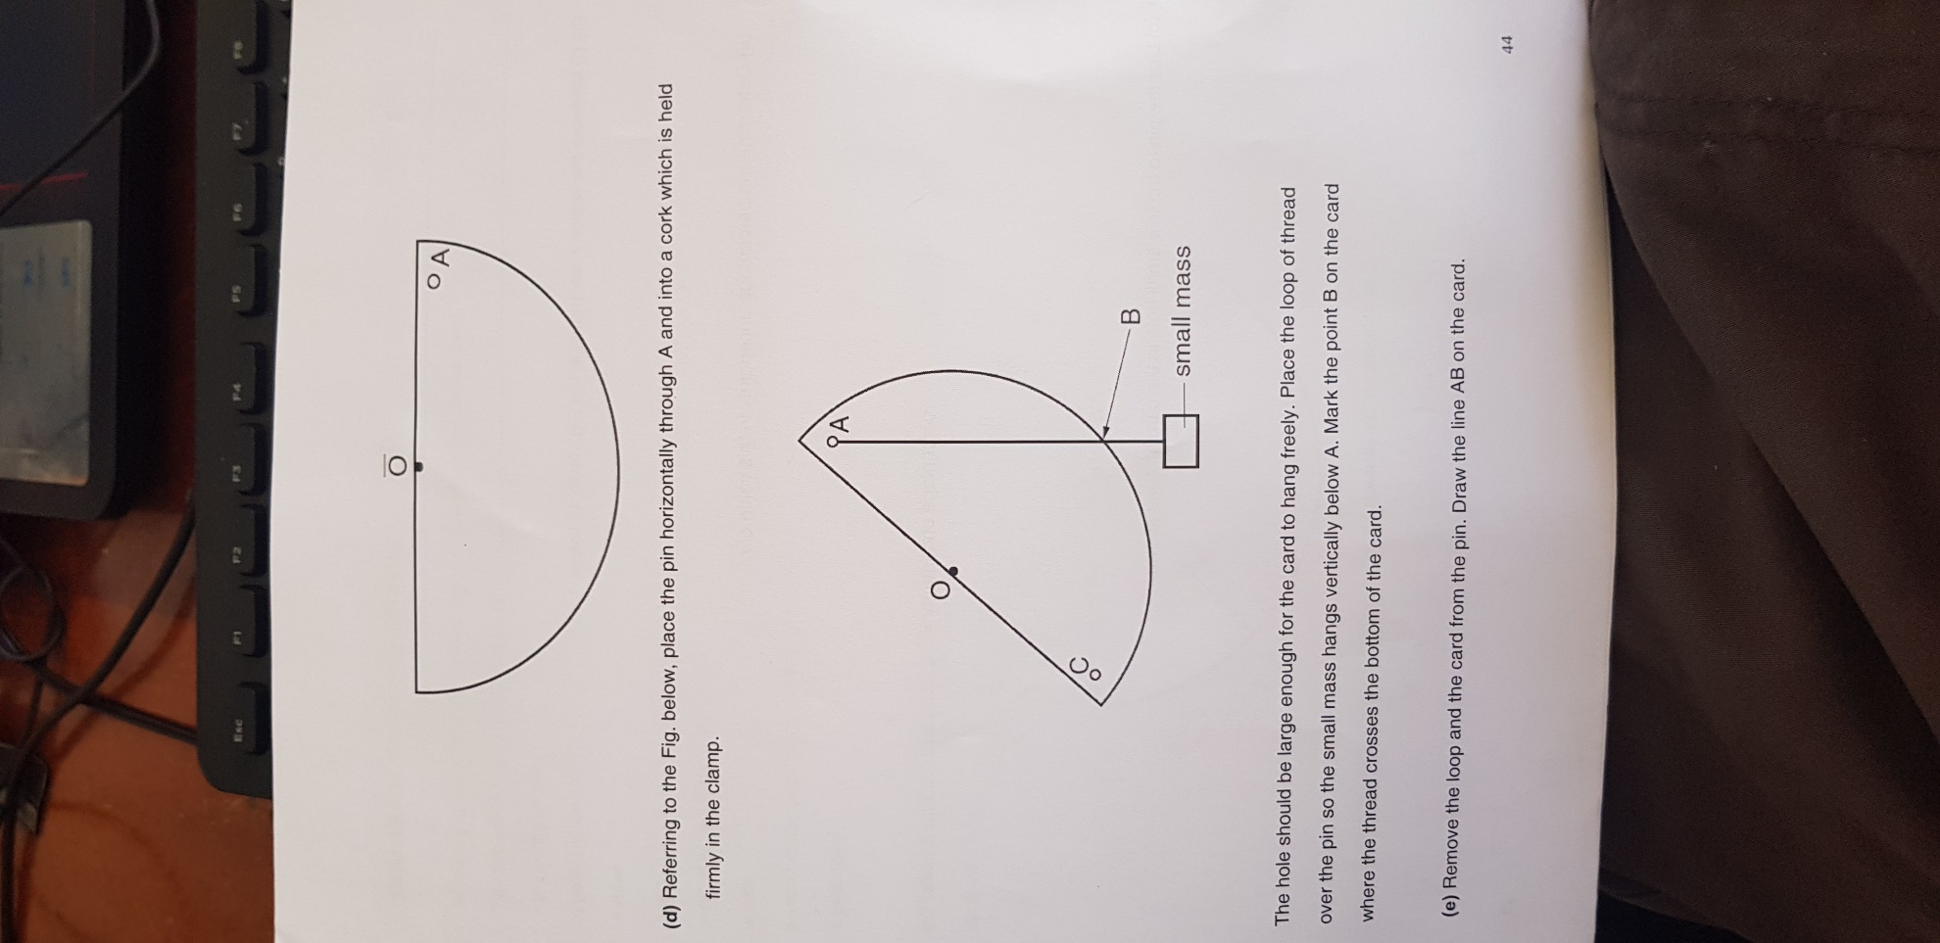Measure the radius r, as shown the fig. note this value

* Determine the percentage uncertainty in this value of r

1. Use the pin to make a small hole in the card at A as shown

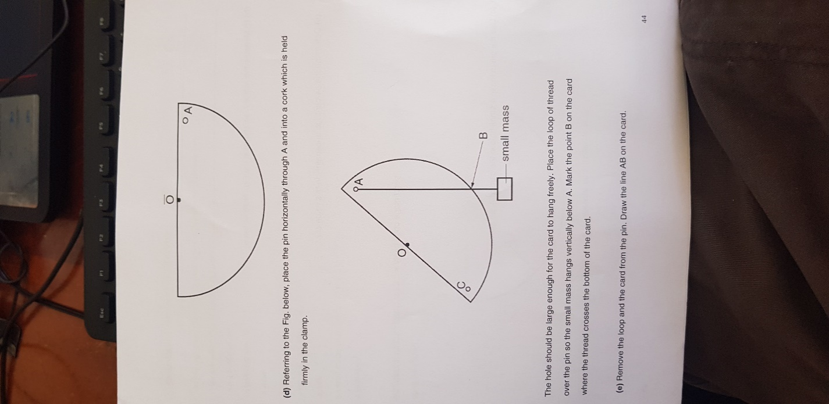

1. Referring to the Fig. below, place the pin horizontally through A and into a cork which is held firmly in the clamp.
2. The hole should be large enough for the card to hang freely. place the loop of thread over the pin so the small mass hangs vertically below A. mark the point B on the card where the thread crosses the bottom of the card
3. Remove the loop and the card from the pin. Draw the line AB on the card.
4. 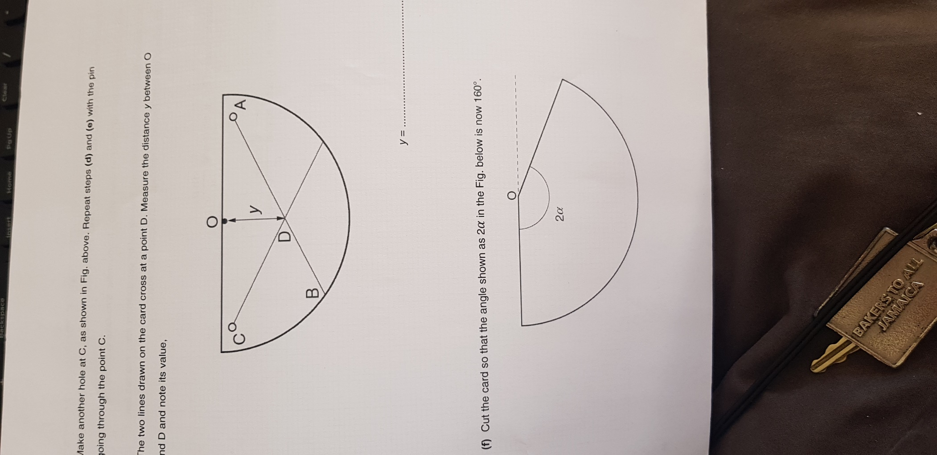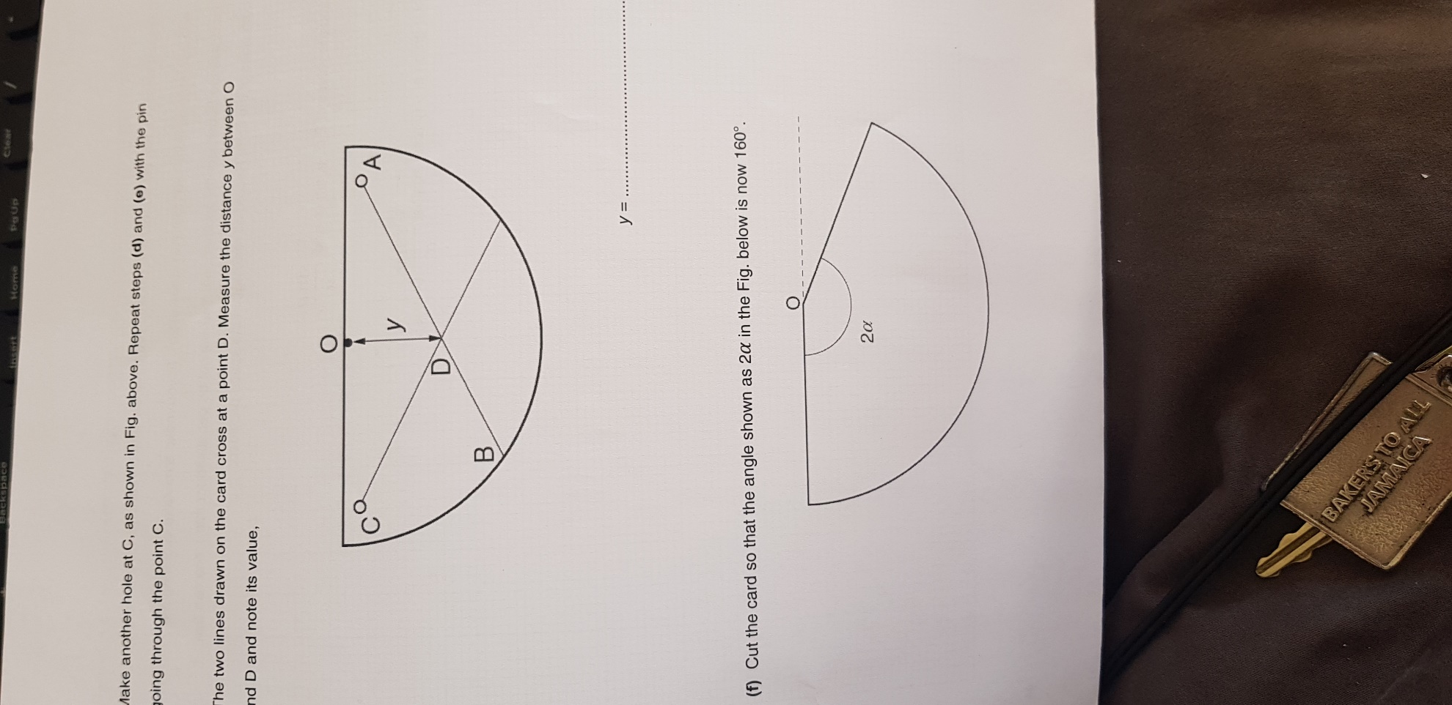Make another hole at C , as shown in the Fig. below. Repeat steps (d and e) with the pin going through the point C
5. The two lines drawn on the card at a point D. Measure the distance y between 0 and D and note its value.
6. Cut the card so that the angle shown as
7. Repeat steps until you have six sets of readings for and y with ranging from 180 to 80 in steps of 20.

Tabulate values of

Plot a graph of y vs

1. Determine the gradient of the line
2. Theory suggests that y =
3. Use your answer to determine r
4. Comment on your value of r

# Lab 14: Circular Motion

**Aim:** To better understand:

1. The difference between speed, velocity & acceleration;
2. How there can be acceleration, even when there is no change in speed.
3. The factors affecting centripetal acceleration.

**Apparatus:** Computer simulation

**Theory:** When an object of mass m moves in a circular path of radius r at the constant speed v, the centripetal acceleration of m is given by:

**Procedure**

**Exercise 2. Racing around a Curve**

1. Click the orange-coloured rectangular box, saying “**Exercise 2 Simulation**” after the descriptive material & figure.
2. You’ll see a racetrack & 2 cars on it: your **RED** car & the **BLUE** car belonging to your competitor (i.e., the computer). Because of the curve, the **RED** car starts in front of the **BLUE** car, so that both of them travel the same distance to the finish line.
3. The track is divided into 3 segments: a) The Speed Change Zone is for speeding up; here, your car will go from rest (0 m/s) to the speed you enter in the box in the **BLUE** region below. This speed is maintained during the rest of the trip in: b) The Straight Constant Speed Zone & c) The Circular Constant Speed Zone.
4. Below the track, on the LHS, you will see 4 metres which will read the speed, acceleration, X-component of the velocity (vx) & Y-component of the velocity (vy) of your car at any time.
5. Next to these, you will see the **BLUE** region with the control panel to change your car’s final speed to any desired value. The commands: GO, RESET & PAUSE are on the RHS. Pressing GO will speed your car from rest (i.e., 0 m/s) to the final (constant) speed you have chosen. When you want to start again, press RESET and then GO.
6. Pressing PAUSE will freeze the car and a second pressing of PAUSE will resume action. The simulation also shows you a velocity vector on your car, indicating its speed & direction of travel.
7. Of course, your aim is to win the race! But then, if you choose a very high speed, your car may spin off the track on the curve!! Try a few different speeds. **Have fun.**

At the same time, observe carefully the metre readings for the speed, acceleration, vx and vy, especially when your car is on the curve.

***Qn. 1*** *Along the curve, your car’s speed is constant. How about vx and vy ?*

***Qn. 2*** *When your car is moving along the curve, the acceleration metre shows a non-zero value. How can your car have an acceleration when its speed is constant?*

**Exercise 3. The Velocity Vector**

1. Click the orange-coloured rectangular box, saying “**Exercise 3 Simulation**” after the descriptive material & figure. You will see a curved track **ABCD**, where **AB**, **BC** & **CD** are straight segments.

In the previous exercise, you chose your car’s final speed, and the computer turned your car automatically to keep it on the track.

1. In this exercise, you choose a value for your car’s speed on the entire track; next, for this speed, you choose vx and vy for each segment of the track, so that your car will stay on the track! If your car goes off the track, press RESET, make the necessary changes to vx and vy and try again.
2. Repeat this for a few other speed values. (Reminder: **Keep the speed the same on the three segments, to within 0.1 m/s.** We use the standard convention that up and to the right are positive while down and to the left are negative).

***Qn. 3*** *Your car’s speed was constant through all the 3 segments of the track. Did your car accelerate? Give reasons for your answer.*

***Qn. 4*** *State the mathematical relation between the speed of your car & its vx and vy.*

**Exercise 4. Curve Radius & Centripetal Acceleration**

1. Click the orange-coloured rectangular box, saying “**Exercise 4 Simulation**” after the descriptive material & figure. You will see a track with two semi-circular turns of radii r1 = 15.0 m & r2 = 7.5 m.
2. Choose a speed for your car. It will travel with this speed for the entire race. (If your speed is too high, your car will leave the track!).
3. Press GO and start the race. Repeat this until you win the race.

***Qn, 5*** *For your winning race, list the following: v; r1 & a1; r2 & a2. How does “a” change with “r”?*

|  |  |  |  |  |  |  |  |  |
| --- | --- | --- | --- | --- | --- | --- | --- | --- |
| r (m) | 8.0 | 9.0 | 10.0 | 11.0 | 12.0 | 13.0 | 14.0 | 15.0 |
| a (m/s2) | 24.5 | 21.8 | 19.6 | 17.8 | 16.3 | 15.1 | 14.0 | 13.1 |
|  |  |  |  |  |  |  |  |  |

***Qn. 6*** *A car is moving at an unknown constant speed vo through a tricky track with 8 semi-circular turns of different radii r. The values of the acceleration “a” at the turns are listed below. Plot the data suitably so as to get a straight line. From your graph, obtain vo. (Hint: Equation 1)*

**Exercise 5. Speed & Centripetal Acceleration**

1. Click the orange-coloured rectangular box, saying “**Exercise 5 Simulation**” after the descriptive material & figure. You will see your car (only) on a circular track.
2. Your aim in this exercise is to investigate how the centripetal acceleration “a” varies with the speed “v” along a circular track of constant radius “r”. For this, choose for your car’s speed any value you like; click GO and notice the acceleration.
3. Now, double the speed and see what happens to the acceleration.
4. In order to make the investigation more scientific, choose 8 meaningful speeds and note the corresponding accelerations.
5. Tabulate your results neatly. (“8 meaningful speeds” means 8 values of the speed, which cover the given range of speeds and which are spread fairly well across the range. Since the acceleration is given correct to 1 decimal only, the error is high – only in this exercise – for speeds less than 5.0 m/s)
6. Plot your data suitably to get a straight line. Hint: Eq. (1)
7. From your graph, obtain the radius of the circular track.
8. If Doug Gore is driving around a circular track and his constant speed is given to you, how will you determine the radius of the track, without using metre sticks or measuring tapes? (Hint: You have a stop watch). Now, go back to the Simulation and measure the radius of the track.
9. Compare the above two results & comment.

# Lab 15: P&D - Forces and Deformation

**Aim:** Plan and design and carry out experiments to examine :

1. The force-extension relationship for a spiral spring that has not exceeded its elastic limit
2. The force relationship for an elastic band
3. The force needed to break an elastic band

**Points to note**

In writing up this experiment please include the following

* Title
* Aim
* All apparatus used
* The method
* Any formula used
* Results
* Calculations
* Sources or error