Introduction to Simple Harmonic Motion
--------------------------------------------------------------------------------------------------
Subject: Physics Week: Feb 10th – Feb 14th 2025
Grade: Lower six (Grade12) Time: 4 hours 40 minutes

Number of sessions:
- 40 minutes
3- 80 minutes
Link to Vision 2030
Goal 1: Jamaicans are empowered to achieve their fullest potential (Vision 2030). This lesson seeks to achieve this goal by enhancing third-form students' problem-solving and critical-thinking skills.

Essential Benchmark (General Objectives):
- Understand the concept of the simple harmonic motion (SHM).

Lesson Objective(s)
Students should be able to:

- Correctly state the conditions necessary for simple harmonic motion.
- Correctly use the equations of SHM (a = -ω²x, x = A sin(ωt), etc.) to solve problems.
- Correctly describe graphically the changes in displacement, velocity, and acceleration during SHM.
Key Skills:
- Communication
- collaboration
- critical thinking
- analytical reasoning
- problem-solving.

Key Vocabulary:
- Suvat Equation
- Power
- Force
- Energy
- Kinetic Energy
- Gravitational Potential

Materials:
- Springs
- Mass
- Pendulum bobs
- Strings
- Protractors
- Markers
- Projector
- Retort Stand
- Meter ruler

Prior Learning:
Students should be able to set up an experiment to determine the period of a simple pendulum.

Procedure

Engage
Students will engage in a class discussion about various types of motion. With the teacher's guidance, students will focus on back-and-forth motion, also known as oscillatory motion. Students will participate in two class demonstrations: first, a spring-mass system will be set up, where they will change the mass and observe the resulting oscillation. Second, they will conduct a simple pendulum demonstration. Following this, students will compare the different types of motion they observed.

Explore
In this phase, students will build on the activities from the engage phase by investigating the relationship between the mass and the period of a spring-mass system. They will collect data, plot graphs, and analyze the results. Additionally, students will explore the relationship between the length of a pendulum and its period, observing the effect of amplitude for small angles.
Explain
The teacher will utilize the whiteboard to define and clarify simple harmonic motions. The teacher will assist students in deriving the equations for simple harmonic motion (x = A sin(ωt), v = Aω cos(ωt), a = -ω²x). The teacher will also guide the class through problems related to simple harmonic motion.
Elaborate
Students will explore simple harmonic motion in chemistry through molecular vibrations of atoms and in biology by examining oscillations in heartbeats. They will brainstorm and create a basic shock absorber using springs and various materials.

Evaluate
Students will review the data analysed it by their colleagues during the exploration phase. Additionally, students will apply the equations of SHM to various problems.

Differentiation:
Fast Learners: Provide extension activities, research projects, and more challenging problems.
Slow Learners: Provide additional support, review basic concepts, and offer more simplified problems.
Cross-Curricular Connections:
Chemistry: Molecular vibrations, bond stretching.
Biology: Biological rhythms, heartbeats.
Music: Vibrations of musical instruments.
Environmental Studies: Earthquake effects on structures.

Reflection:
Students will write what they found challenging. What areas of the concepts are they confident about?

------------------------------------------------------------------------------------------------------------------------------------------------------------------------------------------------------------------------------------------------------------------------------------------------------------------------------------------------------------------------------------------------------------------------------------------------------------------------------------------------------------------------------------------------------------------------------------------------------------------------------------------------------------------------------------------------
Content
Consider the image below.
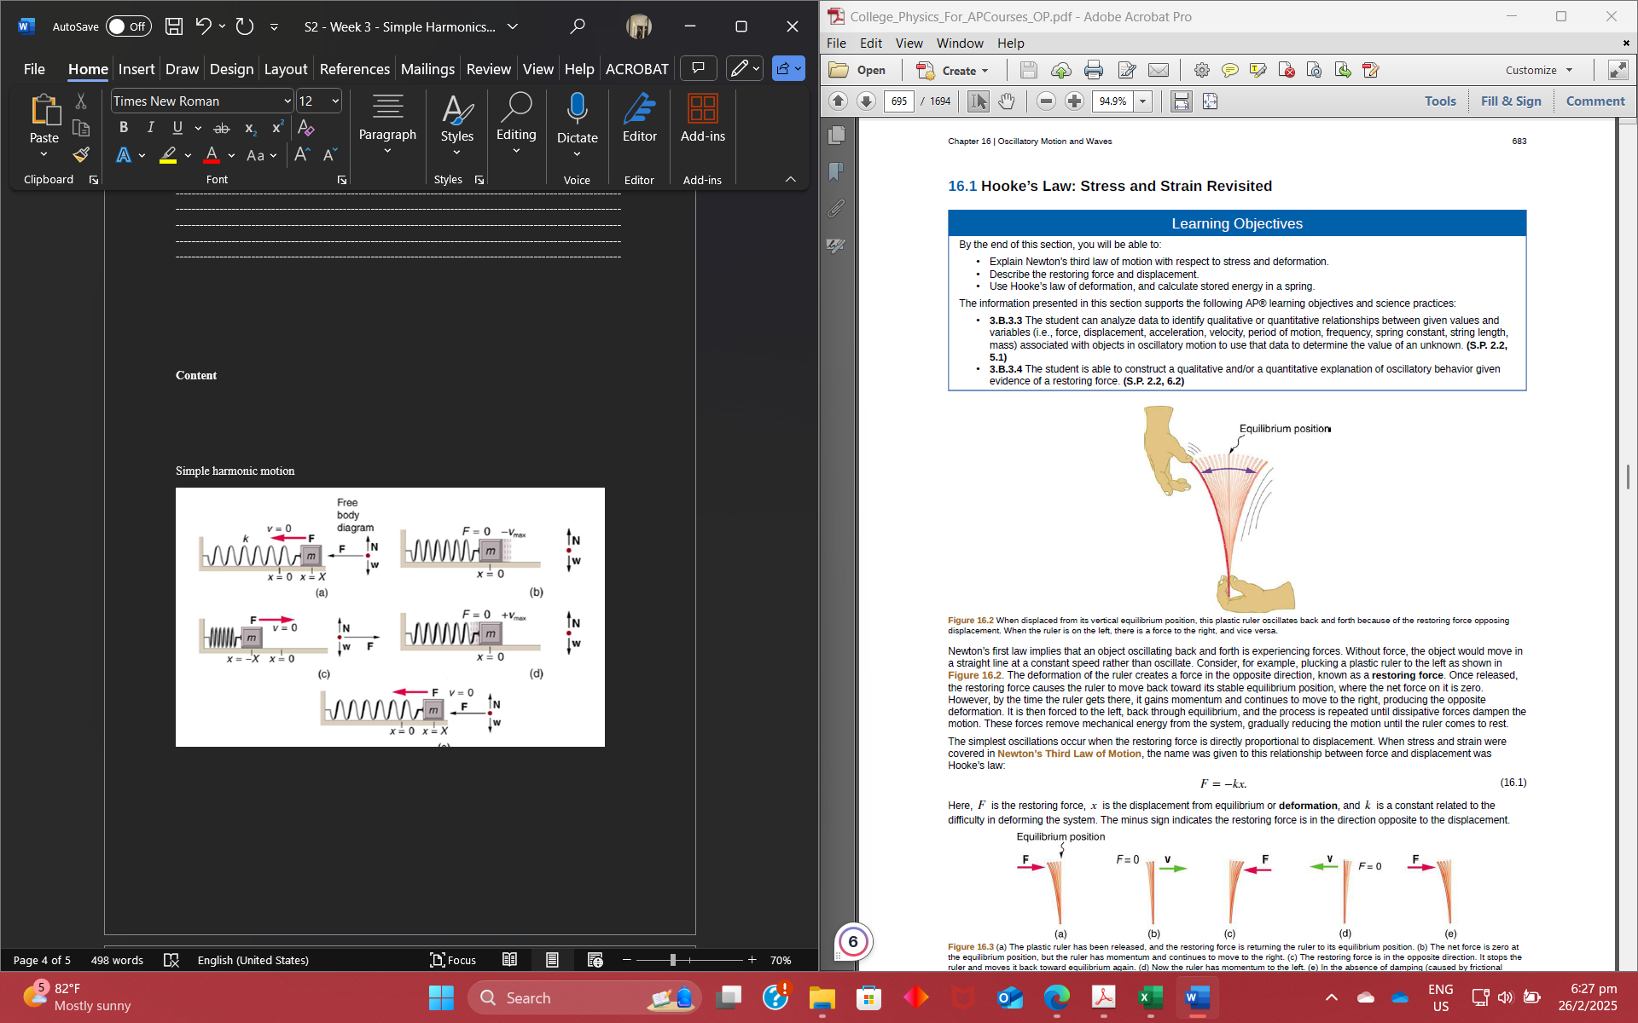
If you look closely, you will see a back-and-forth movement. In fact, the image below
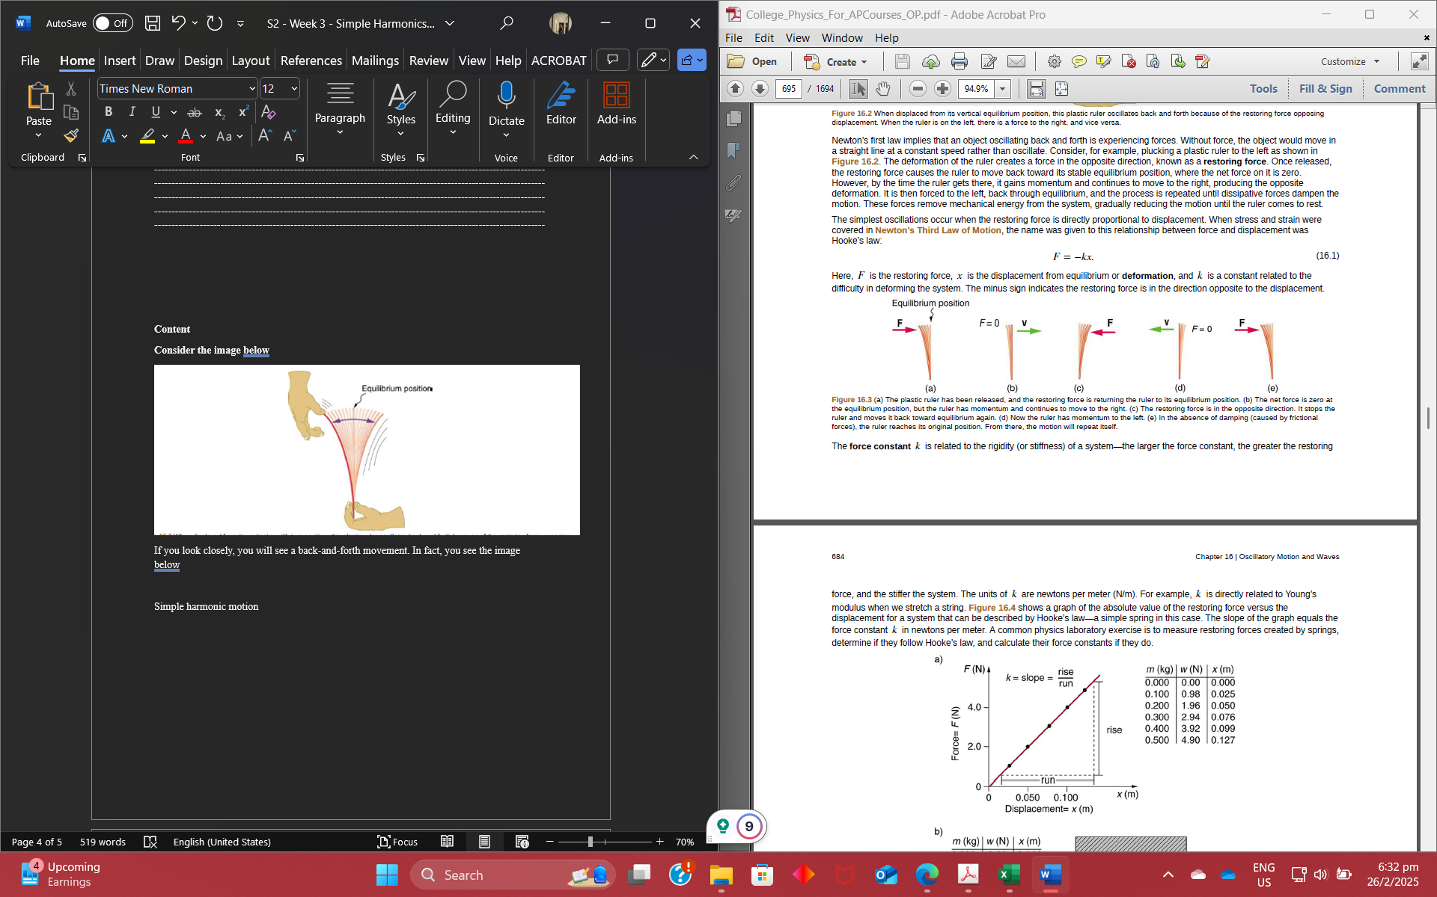
How do we explain this? According to Newton's first law, an object oscillating back and forth is experiencing forces. Without force, the object would move in a straight line at a constant speed rather than oscillate. Consider, for example, plucking a plastic ruler. The deformation of the ruler creates a force in the opposite direction, known as a restoring force. Once released, the restoring force causes the ruler to move back toward its stable equilibrium position, where the net force on it is zero. However, by the time the ruler gets there, it gains momentum and continues to move to the right, producing the opposite deformation. It is then forced to the left, back through equilibrium, and the process is repeated until dissipative forces dampen the motion. These forces remove mechanical energy from the system, gradually reducing the motion until the ruler comes to rest. The simplest oscillations occur when the restoring force is directly proportional to displacement. When stress and strain were covered in Newton’s Third Law of Motion, the name given to this relationship between force and displacement was Hooke’s law: F = −kx.
A Characteristic of oscillatory motion is the time taken to complete one full oscillation. This is called the period. The amplitude of the oscillation is the maximum displacement from the equilibrium position.
The main characteristics of SHM are:
• the period and amplitude are constant
• the period is independent of the amplitude
• the displacement, velocity and acceleration are sine or cosine
functions of time.

Consider the simple harmonic motion of a mass on a spring.
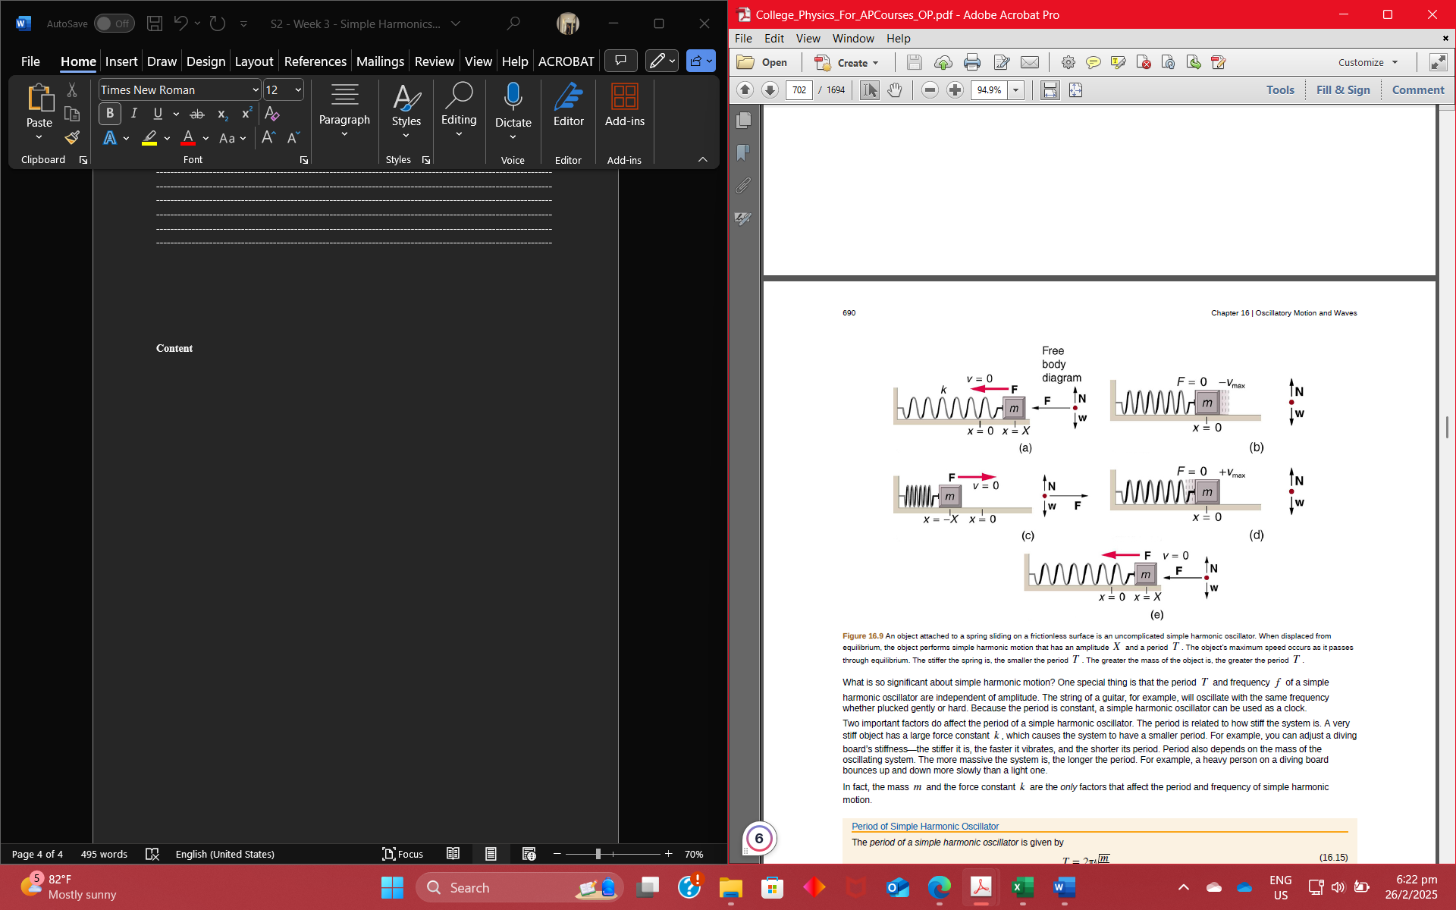

Consider the simple harmonic motion of a pendulum.

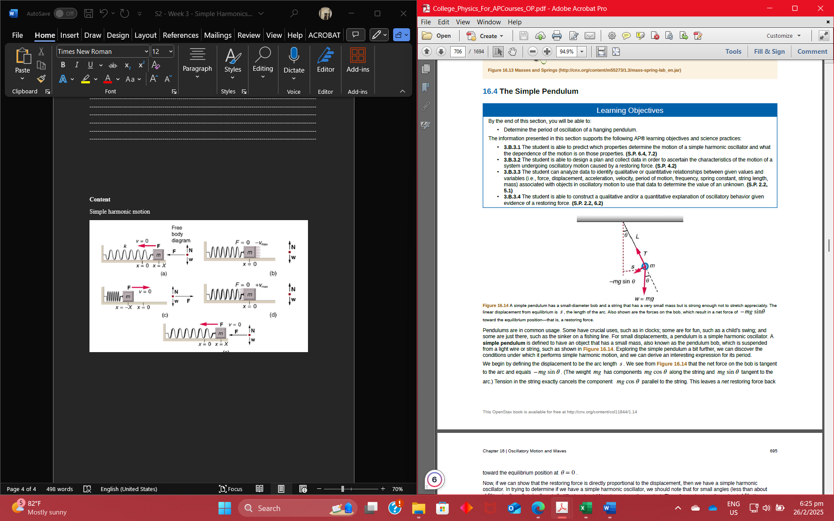
As we go further into simple harmonics, we find Taking displacement to the right of the equilibrium position as positive, then ma = -kx since the tension force is directed to the left, and so is taken as negative. We can rewrite this equation as:
Km =-ax
This tells us that the acceleration has a direction that is opposite to and a magnitude that is proportional to the displacement from equilibrium, so the oscillations will be simple harmonic (assuming there are no frictional forces)
The equation suggests a graph of acceleration and displacement would look like the graph below
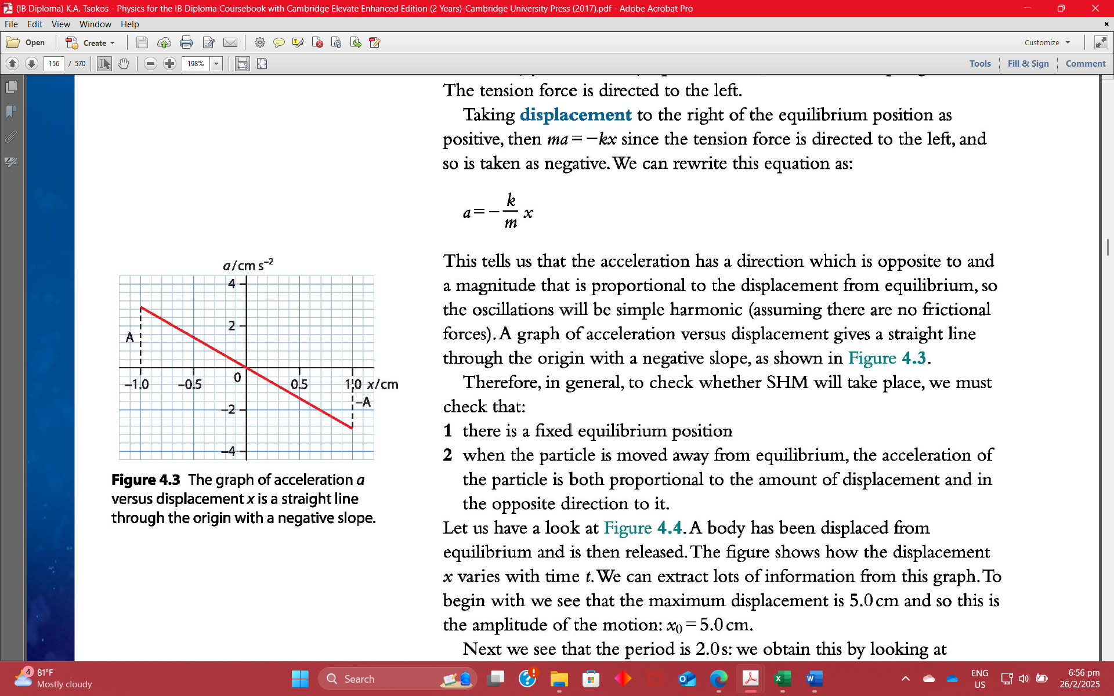

When a mass on a spring oscillates about a fixed point. The displacement as a function of time t that is, one in which the net restoring force can be described by Hooke’s law, is given by x(t) = X cos2πt/T where X is amplitude. At t = 0 , the initial position is x0 = X , and the displacement oscillates back and forth with a period T . (When t = T , we get x = X again because cos 2π = 1 .).
Furthermore, from this expression for x , the velocity v as a function of time is given by:
v(t) = −v (16.21) max sin (2πt/T)
where v_{max} = 2πX / T = X k / m . The object has zero velocity at maximum displacement—for example, v = 0 when t = 0 , and at that time x = X . The minus sign in the first equation for v(t) gives the correct direction for the velocity. Just after the start of the motion, for instance, the velocity is negative because the system is moving back toward the equilibrium point. Finally, we can get an expression for acceleration using Newton’s second law.
According to Newton’s second law, the acceleration is
a = F / m = kx / m . So, a(t) is also a cosine function:
a(t) = −(kX/m) cos2πt/T .
Hence, a(t) is directly proportional to and in the opposite direction to x(t).

